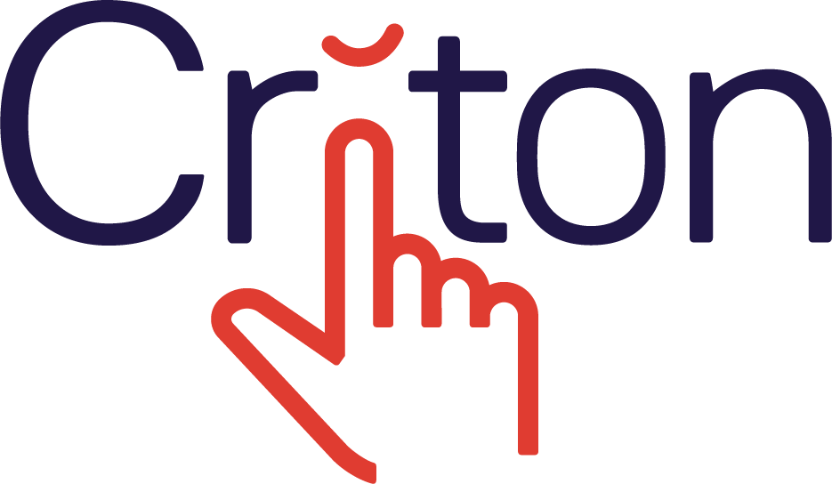
Job Description

Job Title: | Tech Lead
Location/Area: | Edinburgh
Responsible to: | Head of Engineering
Normal hours of work: | NOTIONALLY 40 PW – Occasional requirement to work irregular hours and to travel
Squad/Ownership: | App Squad

Scope and General Purpose of the Job:

You will be the Tech Lead of the App Squad, a small and dynamic cross-functional team, where your role will be focused on leading the development of apps generated by the Criton platform.

Criton is the first DIY app builder for the hospitality industry and allows property owners, ranging from single vacation rental owners to big hotel chain owners to build their own mobile apps. The App Squad is fully responsible for the development, testing and maintenance of the apps generated by the platform.

Responsibilities:
- Implementing user stories and tech stories through clean, maintainable code, together with the squad (at least 75% of the time will be spent coding)
- Setting and documenting coding guidelines, best practices and standards for the area of the codebase which the squad is responsible for (criton-cms, criton-api)
- Working closely with the product manager to maintain the squad’s product backlog and refine and estimate stories
- Proactively managing technical debts by keeping track of them and prioritising tech stories to be addressed
- Owning the technical design process for the part of the codebase which the squad is responsible for (criton-app, criton-distribution)
- Providing mentorship and guidance to other members of the squad
- Identifying headcount needs, communicating them to the Head of Engineering, and working together with the Head of Engineering and recruitment to acquire new talent for the squad
- Participating in performance reviews for members of the squad
- Onboarding new engineers on the squad
- Promptly escalating issues, which affect product delivery and quality, which are beyond scope of influence and reporting them to the Head of Engineering
- Acting as the primary point of contact for the squad

Required skills

- HTML(5), CSS(3), Javascript, Angular 2+
- Experience with Hybrid mobile app development frameworks - Apache Cordova, Ionic
- Familiar with app distribution processes (App Store and/or Google Play Store)
- Familiar with using Restful APIs
- Writing automated tests, Test-driven development
- Ability to work collaboratively with the rest of the product development team to discuss and define requirements
- Version control - Git, Bitbucket or Github
- Proactive and versatile
- Willingness to take ownership and be accountable for one’s work
- Ability and willingness to continuously keep up-to-date with latest technologies and rapidly learn new technologies
- Aspire to engineering excellence – be able to write scalable, maintainable, efficient, and beautiful code
- Previous experience with leading a technical team is an advantage, but not compulsory

Other Duties:

- To carry out such duties as may be reasonably requested from time to time in addition to the main duties associated with the role.
- To be aware of individual responsibility for health and safety of self and others in the workplace and to adhere to the Company’s health and safety policy and procedures.

Key Result Areas:

- The squad delivers quality, low-defect software according to plan and estimates
- Effective communication of updates on progress
- Good documentation to ensure resilience of business
- Meeting deadlines and commitments
- Confidentiality of Company and Client business information as measured by breaches of same.
- Self development to meet the needs of the business.

Constraints:

- Communication with the Press
- Communication with Trades Unions
- Pay rate negotiation or variation of terms of employment.

Job Holder’s declaration:

I have read, understood and agree to carry out the requirements of this Job Description. I further understand that I may clarify any matter associated with this Job Description with the Managing Director.

Employee Signature:

Date:

